**The Recreator 3D**

**DIY Build Notes**

**Designed and Built By:**

**Joshua R. Taylor**

**- With Design Contributions from Nick Jones and Ross Conley.**

**- Contributions from Ross Newkirk, Melissa Savides, Yvette and Allen Taylor,**

**XVICO and Kassie Ma.**

**Thank You to Everyone who made The Recreator 3D Possible!**

**RECREATOR3D.COM - RECYCLE.XYZ - JRT3D.COM - 2021** [**https://www.facebook.com/groups/recreator3d**](https://www.facebook.com/groups/recreator3d)

**Inspired by The Online DIY PET Pultrusion Community and**

**The Need of Recycling Properly for our Future Production Needs!  
  
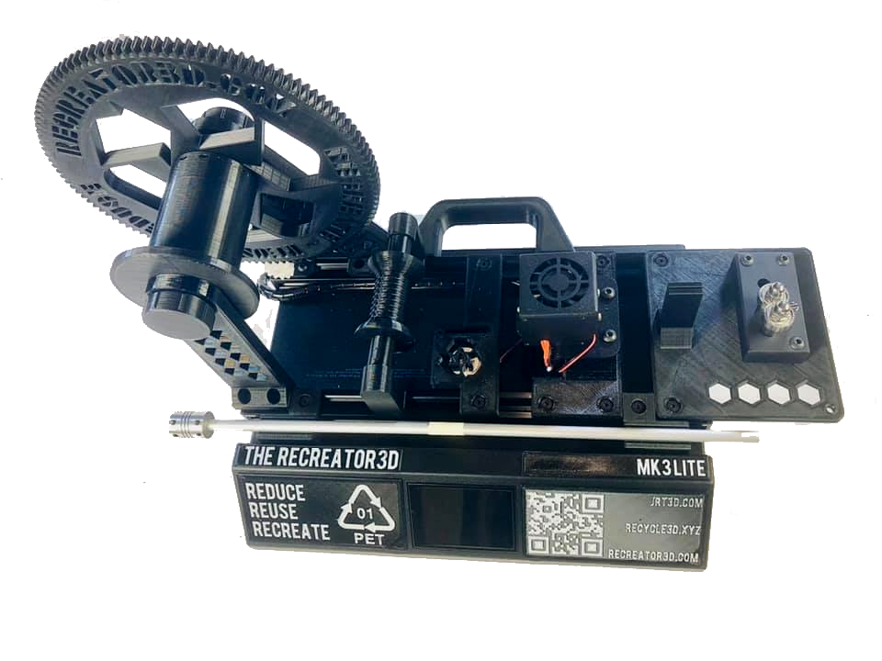**

**BUILD PARTS NEEDED :**

| **$139.00 -**  **https://amzn.to/3hE8ATD -**  **3D Printer Kit Assembly XVICO X3S** |  |  |
| --- | --- | --- |

| **$6.23 -**  **https://amzn.to/3nFxVAn -**  **HHIP 2000-0385 Steel HSS Round Tool Bit, 3/8" x 5" Brand: HHIP  Or can 3D Print: RECREATOR3D - Part 4F - Tensioning Rod.stl** |  |  |
| --- | --- | --- |

| **$29.99 -**  **https://amzn.to/399Wjlx -**  **Plastic bottle cutter**  **Main Site Here:**  **https://plasticbottleandcancutter.com/** |  |  |
| --- | --- | --- |

| **$15.99 -**  **https://amzn.to/3EmWMz4 -**  **HELIFOUNER 1280 Pieces Countersunk Head Socket Cap Screws Bolts, Flat Washers and Nuts Assortment Kit (M2 M3 M4 M5)** |  |  |
| --- | --- | --- |

| **$6.99 -**  **https://amzn.to/3992DK1 -**  **BINZZO Sliding T Slot Nuts 2020 Series M4 50 Pack T Nuts** |  |  |
| --- | --- | --- |

| **$18.99 -**  **https://amzn.to/3lobE7C -**  **SUNLU PETG 3D Printer Filament PETG Black** |  |  |
| --- | --- | --- |

**Total Parts Cost - $220**

**TOOLS NEEDED :**

| **$10.69 -**  **https://amzn.to/3ClMe14 -**  **QWORK 3 Pcs Titanium Step Drill Bit Set** |  |  |
| --- | --- | --- |

| **$14.99 -**  **https://amzn.to/3Ak5H1H -**  **DEWALT Drill Bit Set** |  |  |
| --- | --- | --- |

| **$69.99 -**  **https://amzn.to/3keoFRG -**  **SALEM MASTER Cordless Drill Driver   Or any Drill You’d Rather** |  |  |
| --- | --- | --- |

| **$25.99 -**  **https://amzn.to/3tJOzA7 -**  **Housolution Universal Table Vise 3 Inch  Or any Vice You’d Rather** |  |  |
| --- | --- | --- |

**Total Tool Cost $121.66**

**STEP 0 : PRINT ALL THE PARTS**

**- Decide what Model You’ll Be Printing, MK3Lite or MK3Pro and print the corresponding files. Read the Notes within those Folders to see how to print what parts in which material for best strength.**

**The parts files to 3D Print can be downloaded from here: http://recreator3d.com/parts**

**- After the models are printed, add the M4x8mm screws along with the M4 T Nuts for preparation.**

**STEP 1 : POWER ON THE UNIT**

**- Check the Power’s Voltage Setting for your Country’s Power Needs. Power on the XViCO X3S to make sure the Unit Powers on and the LCD Turns on.**

**STEP 2 : OPEN THE BASE**

**- On the base section of the X3S, turn the unit upside down and remove the 4 screws holding down the base cover (using a Philips Screwdriver)**

**STEP 3 : DISCONNECT THE HEATER BED’S WIRES**

**- Cut the zip tie connecting the wires to the power supply**

**- Detach the thermo wire (white)**

**- Detach the power wire (second in from the right) - (using a flat head screwdriver).**

**STEP 4 : REMOVE THE Z & Y MOTORS AND TRIGGER WIRES**

**- Detach and remove the Z & Y Motors and trigger wires.**

**- Detach the breaker switch (but don’t remove)  
  
- Detach the X motor wire and trigger wire (but don’t remove) the X wire; attached to the main wire array, is for dual motor users.**

**- If using the MK3Lite - Single motor system, remove the X, Y, and Z Driver Boards.**

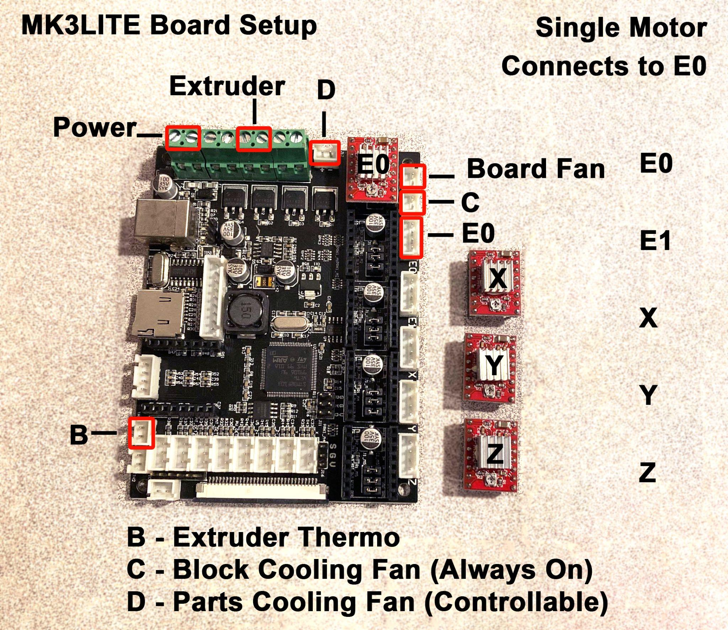

**- If using the MK3Pro - Dual motors, Remove all the Stepper Driver boards and use the X & Y Stepper Driver boards and swap them over to E0 & E1. The Extruder and X Wires Will be plugged into E0 & E1.**

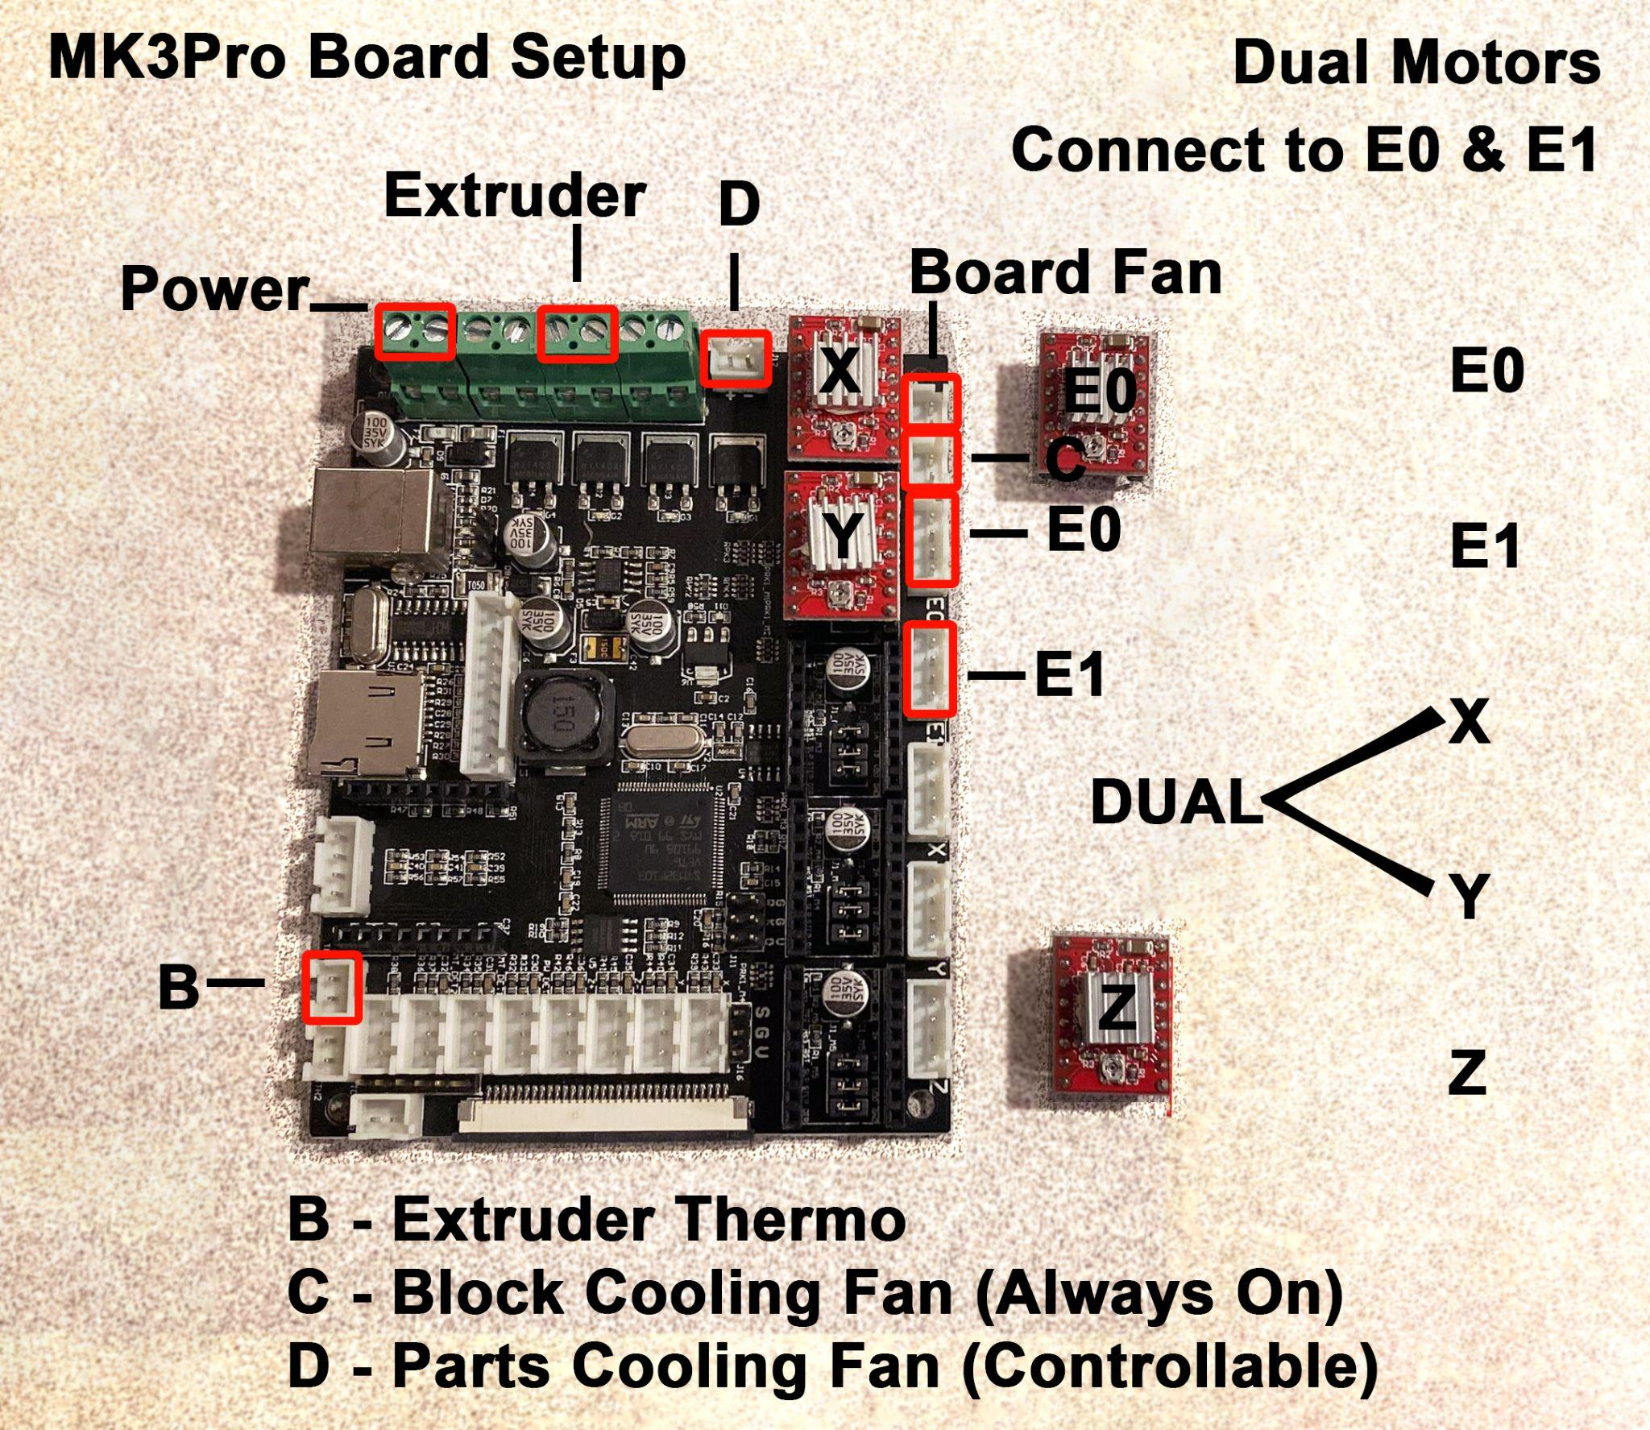

**- ZipTie remaining wires to the Power Supply where you cut them off from initially.**

**- Reattach the back cover with the 4 screws (using a Philips Screwdriver)**

**STEP 5 : REMOVE THE BED**

**- Cut the ZipTie connecting the Belt to the front of the Plate and pull the belt backwards.**

**- Loosen the 4 screws on the front belt tensioner and dismount from the 2040 rail (using size 2.5 Hex Tool).**

**- Move the heated bed forward to remove it from the 2040 rail.**

**STEP 6 : DISSEMBLE THE BASE FRAME**

**- Remove the middle 2040 Rail first, taking out the 4 hex screws (using size 4 Hex Tool). (If using the Dual Motor Setup, put the Y Motor from the back of this rail to the side.)**

**- Remove the remaining 10 screws, 8 in the front and 2 in the back (using size 4 Hex Tool).**

**- Dismantle the rest of the base frame. Remove the 4 Screws (8 total) along each end of the frame (using size 4 Hex Tool).**

**- The 2 smaller 2020 Rails will be used on the base.**

**- Mount the 2020 Rails to the Base using 4 Screws taken out from the above steps. Install the screws onto the outter the Holes on the rails, not the inner Holes.**

**- If no end caps are on these 2020 rails, you can take some from the top frame.**

**STEP 7 : DISSEMBLE THE UPPER FRAME**

**- Loosen the Lead Screw Coupler at the 2 screws (using size 3 Hex Tool). Save the Coupler, it will be used as a safety cap on the Bottle Support Rod.**

**- Unscrew the Lead Screw.**

**- Dismount the Motor Mount with the motor attached, unscrewing the 2 screws (using size 2.5 Hex Tool).**

**- Dismount the Z Switch Bracket (using size 2.5 Hex Tool).**

**- Remove the 2020 Gantry Arm from the 2 - 2040 rails of the top frame.**

**- Cut the ZipTies at the mounting plates bracket to release the belt.**

**- Loosen the belt tensioner bracket on the right side of the gantry arm (using size 2.5 Hex Tool).**

**- Take the PTFE Tube out of the coupler**

**- Slide off the Head from the 2020 Rail.**

**- Remove the 3 wheels from the plate on the right side of the gantry arm. Save the 3 Screws and Nuts, they’ll be used to connect the bottle cutter to the base frame.**

**- If using the Single Motor Setup, Remove the Extruder Gear Motor. Unscrew the 3 Hex Screws Holding down the Cover (using size 2.5 Hex Tool). Remove the last (4th) screw holding the Motor to the Frame. To finally release the motor, unscrew the grub screw in the Extruder gear (using size 1 Hex Tool).**

**- If using The Dual Motor Setup, Remove the X Motor on the left side of the Gantry arm, loosening the 4 screws (using a Philips Screwdriver). This should match up with the Y motor from the previous step.**

**STEP 8 : MOTORS**

**- If Using a Single Motor Setup, dismount the Z Motor’s Mounting Bracket and Install it onto the Extruder Gear Motor. Make sure the Motor’s Power Connector is pointed down matching the plate’s mount (using a Philips Screwdriver)**

**- If using The Dual Motor Setup, match the 2 twin matching motors together and install them onto the *“RECREATOR3D - Part 5B - Spool Holder - PRO - DUAL MOTOR”* mount with 4 - M3x12 Hex Screws per motor (using size 2 Hex Tool).**

**STEP 9 : DISMANTLE THE EXTRUDER HEAD**

**- Unscrew and Remove the 2 Screws holding the Shroud (using size 2.5 Hex Tool).**

**- Unscrew and Remove both Fans from the Shroud (using a Philips Screwdriver).**

**- Unscrew and Remove the 2 screws connecting the Heat Sink to the Plate - Be mindful of the washers for reinstallation (using size 2.5 Hex Tool).**

**- Unscrew and Remove the PTFE Coupler Connector (using a Wrench and/or Pliers).**

**- Unscrew and Remove the M2 Screw holding the Heat Block to the Heat Sink (using a Philips Screwdriver).**

**- Unscrew and Remove the small Grub Set Screw holding the Heat Break from the Heat Sink (using a Wrench and/or Pliers)**

**- Unscrew and Remove the Heat Break from the Heat Block (using a Wrench and/or Pliers).**

**- Unscrew and Remove the Nozzle from the Heat Block (using a Wrench and/or Pliers).**

**\*\*\* Be Mindful and Very Careful with the Heat Block and the Thermo/Heater wires. These are delicate wires. The following work can be done with the wires still attached if you trust your skills. They can also be taken off and put back on after the following work. Be advised and do what is best for yourself. These notes will be leaving the wires attached to the block. Again, Take extreme caution in handling these wires so as to not damage them. \*\*\***

**- Take the Wheels off of the Head Plate and put the Screws and Nuts aside for the Mounting Plate Assembly (using a Wrench and/or Pliers, Philips ScrewDriver and a 3 Hex Tool).**

**STEP 10 : DRILLING THE PARTS**

**You’ll need the following Tools:**

**- Drill**

**- Vice Clamp**

**- 3/16”-½” Six-Step Bit - Rounding the Heat Sink**

**- 1/16th Drill Bit - Nozzle - 1.60mm**

**- 7/64th Drill Bit - Drilling the Heat Sink and the Heat Block Holes**

**- 3/16th Drill Bit - Drilling the Bottle Cutter’s Holes  
  
- Set the Heat Block into the Vice Clamp with the Wires set to the side (make sure you DO NOT CLAMP the wires). Using the 7/64th Drill Bit - Drill the 2 Holes until they are slightly bigger than the bit; with a good rounding. Sand the Sides Lightly if needed. Unclamp and put to the side.**

**- Set the Heat Sink into the Vice Clamp with the Single Grub Screw Hole Facing Upwards. These 2 holes will be connecting the Heat Block. Using the 7/64th Drill Bit - drill the 2 Holes, you will instantly feel once you are through and that should be enough. Sand the Side Lightly if needed.**

**- Unclamp and flip upside down and reclamp.**

**- With the Heat Sink now upside down (the Grub Screw Hole should be facing down), drill out the center. Using 3/16”-½” Six-Step Bit - Drill through the center core until you hit the ½” mark on the**

**Drill Bit. You will be able to just Round the top with the last step in the bit. Avoid going any lower than this as you can blow out the holes for the Shroud. Sand the Side Lightly if needed. Unclamp and put to the side.   
  
- Set the Nozzle into the Vice Clamp with the tip downwards. With your drill in low torque; using the 1/16th Drill Bit, Drill downwards into the nozzle to form a 1.60mm hole. Sand the Tip Side Lightly if needed.**

**- Set the Bottle Cutter into the Vice Clamp. With the 3/16th Drill Bit - Drill the Bottle Cutters Holes to accommodate the 3 Screws and Nuts reclaimed from the Gantry’s Right Side. You can attach the bottle cutter to The Cutter Plate *“RECREATOR3D - Part 1 - Cutter Plate”* using these 3 Screws and Nuts saved from the previous steps.**

**STEP 11 : REASSEMBLE THE HEAD**

**- Set the 2 - M3x16 Screws into the Heat Block to the Heat Sink. The holes are slightly smaller, with some pressure the screws will set themselves into the Heat Block and then Set into the Heat Sink. These two parts should sit flush with each other, though a small gap is acceptable (using size 2 Hex Tool).**

**- Attach the Head Plate to the Heater Block Plate “*RECREATOR3D - Part 2 - Heater Block Plate - PETG”*, Using the original 3 Screws and Nuts. Locking them in place. (using a Wrench and/or Pliers, Phillips ScrewDriver and a 3 Hex Tool).  
  
- Set the 2 Screws into the Heat Sink and attach it to the Head Plate with washers in between (using size 3 Hex Tool).**

**- Screw the Nozzle onto the Heat Block making sure the wires are on the right side (using a Wrench and/or Pliers).**

**- Reattach the Main Fan to the shroud, making sure the wire side is facing down towards the base of the shroud. Lining up to where the Heater and Thermo Wires sit. Make sure the sticker side is facing towards the Heat Sink (using a Philips Screwdriver).  
  
- Reattached the Shroud using it’s original screws. It’s good to add a ZipTie to these 3 Wires at the base of the Shroud. (using size 2.5 Hex Tool).  
  
- Using the original 4 Screws, Attach the Parts Cooling Fan to the Printed Bracket *“RECREATOR3D - Part 3 - Cooling Fan Plate”*, Making sure the sticker side is facing up with the blower facing down (using a Philips Screwdriver).**

**STEP 12 A : COMPLETE THE REST OF THE BUILD**

**With the Bottle Cutter Mounted, along with the Head and Blower Fan...These Parts can now be mounted onto the base frame along the 2 - 2020 Rails.**

**- Attach the Cutter Plate towards the right side of the frame. Set the Screws and T Nuts in place on the right side of the main screw holding the 2020 (using size 2 Hex Tool).**

**- Attach the Heater Block Plate with 1 inch in between the Cutter Plate. Set the 4 Screws and T Nuts in place on the 2020 (using size 2 Hex Tool).**

**- Attach the Cooling Fan Plate 1.25 inches from the Heater Block Plate. Set the 2 Screws and T Nuts in place on the 2020 (using size 2 Hex Tool).**

**- Run the Wire Array Cable along the back 2020 Rail and tuck it inside the Rail. Follow the Rail until you reach the hole in the base.**

**STEP 12 B : SINGLE OR DUAL MOTOR BUILD**

**MK3Lite Single Motor Build**

**- For the MK3Lite Single Motor Build, Remove the 2020 End Caps on the Right Side of the Rails. Attach the Extruder Motor On the Back Rail on the outer edge, making sure the T Nut is Set Flushed so that the End Cap can easily snap back in place. Place the *“RECREATOR3D - Part 8 - Small Gear WIDER”* onto the motor shaft (using size 2 Hex Tool).**

**- On the Front 2020 Rail set the *“RECREATOR3D - Part 5A - Spool Holder”* in place on the outer edge, making sure the T Nut is Set Flushed so that the End Cap can easily snap back in place (using size 2 Hex Tool).**

**- Using the “RECREATOR3D - Part 7A - Spool Rod” as a guide for straightness, Set the *“RECREATOR3D - Part 5B - Spool Holder - LITE - Single”* on the back 2020 Rail, Set the 2 Screws and T Nuts in place on the 2020, about 2.5 inches from the edge (using size 2 Hex Tool)**

**MK3Pro Dual Motor Build**

**- For the MK3Pro Dual Motor Build, Remove the 2020 End Caps on the Right Side of the Rails. Attach the Dual Extruder Motors On the Back Rail on the outer edge, making sure the T Nut is Set**

**Flushed so that the End Cap can easily snap back in place. Place the *“RECREATOR3D - Part 8 - Small Gear WIDER”* onto the motor shaft (using size 2 Hex Tool).**

**- On the Front 2020 Rail set the *“RECREATOR3D - Part 5A - Spool Holder”* in place on the outer edge, making sure the T Nut is Set Flushed so that the End Cap can easily snap back in place (using size 2 Hex Tool).**

**- Using the *“RECREATOR3D - Part 7A - Spool Rod”* as a guide for straightness, Double check these two parts are straight on the back 2020 Rail, Double check the 2 Screws and T Nuts in place on the 2020, about 2.5 inches from the edge (using size 2 Hex Tool).**

**STEP 12 C : THE END OF THE TUNNEL**

**- Combine all Parts for *“PART 6 - Spool”*. Due to the way the Spooler Spins, it’s suggested to use some super glue to hold these parts together when screwed together to form one part. Otherwise the parts can become loose, separate, and bind while the unit is running.  
  
- Combine all Parts for *“PART 7 - Spool Rod”*. Attach *“PART 6 - Spool”*, to the Spool Holder with *“PART 7 - Spool Rod”*. Setting the Spacer towards the back to allow Small Gear Clearance. Lock the Rod in place with the *“PART 7 - Rod Nuts”.***

**- Combine all Parts for *“PART 4”* with theSteel HSS Round Tool Bit and Attach The Tensioner with 1 inch in between the Cooling Fan Plate, but ultimately flushed set against the back Spooler Arm. Set the 2 Screws and T Nuts in place on the 2020 (using size 2 Hex Tool).**

**- Attach the *“RECREATOR3D - Part 09A&B - Bottle Support Holder”* on the Right and Left Side of the front 2020 Rail. Right side in between the cutter plate and heater block plate. Left side set along the spool holder. Set the 2 Screws and T Nuts in place on the 2020 (using size 2 Hex Tool).**

**- Attach the *“Rail RECREATOR3D - Part 12 - Handle”* on the Back of the Back 2020 Rail. Set the 2 Screws and T Nuts in place on the 2020 (using size 2 Hex Tool).**

**- Attach the Front Signage (using Double Sided Tape).**

**- On the Base Section of the Recreator 3D, Turn the unit upside down and remove the 4 screws holding down the base cover (using a Philips Screwdriver)**

**- Place the Wire Array inside the Hole, Tuck the wires to the side. Connect the Wire Array together, but connect C to D and D to C to reverse the Fans. Extend the Motor Wires out of the Hole and ZipTie the Array to the 2 Smaller holes to set the wire in place. Replace the base and 4 screws. (using a Philips Screwdriver)**

**STEP 13 : UPDATE THE FIRMWARE**

**- Go to** [**http://www.recreator3d.com/software**](http://www.recreator3d.com/software) **and download the latest “xvico.bin” file. Place this file onto a Micro SD Card and insert it into The Recreator 3D’s SD Card Port. Turn on the unit. The unit will start flashing with the current firmware. Once finished. Remove the Micro SD Card and delete the “xvico.bin” file from the Card. Your unit is now current.**

**Congratulations!**

**You’ve Completed**

**The Recreator 3D Build!**

**What Will You Recreate?  
  
Thanks for Recycling!**

**DONATIONS ARE WELCOME!**



**Scan the QR to Donate and help with Future Projects!**

**Consider supporting the good work Joshua R. Taylor does by donating or sharing with others who'd like to help.**